Multimodal Deep Learning Framework for Brain Tumor Segmentation Using CT and MRI Images with Improved Genetic Algorithm Optimization

Authors Name/s per 1st Affiliation (Author) FirstName Surname
line 1 (of Affiliation): dept. name of organization
line 2: name of organization, acronyms acceptable
line 3: City, Country
line 4: e-mail address if desired

Authors Name/s per 3rd Affiliation (Author)* FirstName Surname
line 1 (of Affiliation): dept. name of organization
line 2: name of organization, acronyms acceptable
line 3: City, Country
* Corresponding author: e-mail address if desired
Authors Name/s per 2nd Affiliation (Author) FirstName Surname
line 1 (of Affiliation): dept. name of organization
line 2: name of organization, acronyms acceptable
line 3: City, Country
line 4: e-mail address if desired

Authors Name/s per 4th Affiliation (Author) FirstName Surname
line 1 (of Affiliation): dept. name of organization
line 2: name of organization, acronyms acceptable
line 3: City, Country
line 4: e-mail address if desired

Abstract—Brain tumor segmentation plays a critical role in medical imaging, aiding in diagnosis, treatment planning, and prognosis. This study proposes a novel multimodal deep learning framework for brain tumor segmentation using both CT and MRI images, combined with an Improved Genetic Algorithm (IGA) for post-processing optimization. The framework leverages complementary information from CT and MRI, using a U-Net-based model for initial segmentation, followed by IGA to refine the results. Experiments on datasets including CT-Brain-Segmentation285 and Brain MRI Images for Brain Tumor Detection show that our approach outperforms traditional methods in accuracy (Dice coefficient: 94.1%) and efficiency (45% faster than standard GA). The method provides a robust tool for clinical brain tumor analysis.
Keywords- Image segmentation, genetic algorithm, OTSU algorithm, CT image, skull segmentation

Introduction (Heading 1)
With the advancement of medical imaging technology, accurate segmentation of brain tumors has become crucial for diagnosis, treatment planning, and surgical guidance. Multimodal imaging, combining computed tomography (CT) and magnetic resonance imaging (MRI), provides complementary information: CT offers high-resolution bone structure and hemorrhage details, while MRI excels in soft tissue contrast and tumor characterization[1]. However, effectively integrating these modalities remains challenging due to differences in imaging principles and spatial alignment. Traditional segmentation methods often struggle with intensity inhomogeneity and complex tumor boundaries[2]. Deep learning approaches, particularly convolutional neural networks (CNNs), have shown promise in handling multimodal data. This study proposes a multimodal deep learning framework fused with an Improved Genetic Algorithm (IGA) to enhance brain tumor segmentation accuracy and robustness[3].
Research Objectives and Contributions. This study aims to develop a multimodal deep learning framework for brain tumor segmentation by integrating CT and MRI images[4]. Our main contributions include: (1) proposing a U-Net-based architecture with attention mechanisms for feature-level fusion of CT and MRI data; (2) incorporating an Improved Genetic Algorithm (IGA) for post-processing optimization of segmentation boundaries; (3) validating the framework on publicly available CT and MRI datasets with comprehensive metrics including Dice, Hausdorff Distance, and ASSD[5].
Conventional approaches to medical image segmentation often rely on (semi-)automatic rule-based methods, including edge detection, region-based strategies, and level sets. A key advantage of these methods is their computational efficiency in terms of processing time and memory usage[6]. However, they typically require the manual formulation of generic prior rules to guarantee segmentation accuracy, which becomes challenging when handling images with significant noise or artifacts. In response to these limitations, data-driven methods have been developed[7]. Unlike rule-based techniques, data-driven approaches do not depend on a fixed set of hand-crafted rules; instead, they learn relevant features from large datasets of medical images. Commonly used data-driven techniques in medical image segmentation include random forests, statistical shape models, and atlas-based methods. Although these methods often achieve higher segmentation accuracy compared to rule-based approaches, they still face limitations in generalizing across medical images with diverse shapes, sizes, and imaging characteristics[8]. Moreover, their performance tends to degrade when applied to images acquired from different CT scanners or under varying imaging protocols.
In recent years, the rapid advancement of deep learning, particularly convolutional neural networks (CNNs), has ushered in a new era for medical image segmentation. Deep learning models excel at automatically learning hierarchical features from vast amounts of annotated data, capturing intricate patterns that are often imperceptible to traditional methods. For abdominal CT segmentation, architectures such as U-Net, with its encoder-decoder structure and skip connections, have become the de facto standard, demonstrating remarkable performance in segmenting organs like the liver, kidneys, and spleen[9,10]. These models can effectively handle variations in organ shape, size, and appearance across different patients, while also exhibiting robustness against common imaging artifacts such as partial volume effects and inhomogeneous contrast enhancement. Furthermore, the integration of attention mechanisms, transformer architectures, and adversarial training schemes has pushed the boundaries of segmentation precision, enabling finer delineation of organ boundaries and pathological regions[11]. Despite these successes, challenges remain, including the need for large-scale labeled datasets, model interpretability, and real-time processing requirements in clinical settings. Ongoing research continues to address these issues, aiming to develop more efficient, adaptable, and trustworthy deep learning solutions for abdominal image analysis.
Research Objectives and Contributions. While the principles of image segmentation are universal, the specific challenges of medical imaging—such as low contrast, anatomical variability, and the critical need for accuracy—require tailored solutions. This study specifically addresses the problem of skull bone segmentation from cranial CT scans, a task crucial for surgical planning, trauma assessment, and biomedical research. To tackle the limitations of traditional thresholding and evolutionary algorithms, we propose an Improved Genetic Algorithm (IGA). Our contributions are threefold: (1) We adapt and optimize the IGA for the specific domain of skull CT segmentation; (2) We validate our method on a clinically relevant, ethically approved dataset consisting solely of human cranial CT images; and (3) We employ standard medical image segmentation metrics to provide a rigorous and unambiguous evaluation of performance.
Recent advances in deep learning have revolutionized medical image segmentation. Convolutional Neural Networks (CNNs), particularly U-Net and its variants, have demonstrated remarkable performance in various medical segmentation tasks. However, most existing approaches focus on single modalities or simple fusion strategies, without fully leveraging the complementary nature of CT and MRI data. Moreover, post-processing optimization using traditional algorithms often fails to refine complex tumor boundaries effectively.
Research Objectives and Contributions. This study addresses these limitations by proposing a comprehensive multimodal framework for brain tumor segmentation. Our main contributions include: (1) developing a dual-channel U-Net architecture with attention mechanisms for effective CT-MRI feature fusion; (2) incorporating an Improved Genetic Algorithm (IGA) with adaptive mutation and elite retention strategies for post-processing optimization; (3) validating the framework on clinically-relevant datasets using rigorous evaluation metrics including Dice Similarity Coefficient (DSC), Hausdorff Distance (HD), and Average Symmetric Surface Distance (ASSD).

CT Image Segmentation Method Based on Image Segmentation
With the adoption of computer-aided diagnosis and medical imaging for clinical support, the diagnostic efficiency of healthcare professionals has been significantly enhanced, drawing increasing attention from researchers. Image segmentation serves as a fundamental and challenging task in the fields of image processing and computer vision. It refers to the process of partitioning an image into multiple regions with distinct properties to extract regions of interest. As a core technique in computer vision, it also forms a critical bridge from low-level image processing to high-level image analysis, enabling more advanced tasks such as feature extraction and parametric measurement. The accuracy of segmentation is vital, as it directly affects the performance of all subsequent processing steps.
Compared to other modalities, CT imaging offers lower soft tissue contrast but high density resolution, making it particularly suitable for visualizing bones, muscles, and certain organs. A CT scanner acquires cross-sectional images of the human body using highly sensitive detectors. It is characterized by rapid scanning speed and high image clarity. Although each scan involves radiation exposure and usually requires a contrast agent, CT remains one of the most affordable and widely used medical imaging techniques. In contrast, magnetic resonance imaging (MRI), which uses radio waves, provides the highest spatial resolution and excels in soft tissue visualization (e.g., brain structures) and functional imaging. However, MRI has limitations including lower sensitivity, longer acquisition times, and moderate cost. Due to data availability constraints—specifically, the fact that only annotated CT image datasets are currently publicly accessible for liver segmentation—this study utilizes CT images [12].
CT scanners emit X-rays that traverse different tissues and organs, generating varied response values based on tissue density and composition. The output of CT equipment is typically stored in DICOM format, which requires specialized interfaces for data reading and image loading. Due to variations in CT scanner models and manufacturers, the grayscale value ranges of resulting images can differ significantly. To properly visualize DICOM images, it is necessary to adjust the window width and window level settings, which truncate pixel values to a specified range. Values within the window width are linearly transformed into the [0, 255] intensity interval, as defined in formula (1):
(1)
where 255.0 is the original image data, W is the window width value, C is the window level value, and G(V) is the converted pixel value.
A significant step forward came with the OTSU algorithm, which uses the grayscale histogram of an image for threshold selection. By analyzing the distribution of pixel intensities, the algorithm automatically determines an optimal segmentation threshold by maximizing inter-class variance, eliminating the need for manual estimation. Despite its automation, a major drawback of OTSU is its high computational cost due to the extensive operations required to identify the optimal threshold. If represented in matrix form, the computation involves variables such as the one originally given in formula (2).
To mitigate the computational burden, some studies have attempted to implement OTSU using specialized hardware or optimized calculation principles, though with limited success. Furthermore, the method tends to perform poorly on images with irregular or multimodal grayscale distributions, where clear peaks are absent, leading to unreliable segmentation.
Subsequent advances saw the incorporation of evolutionary algorithms, particularly Genetic Algorithms (GA), into image segmentation. GA offers a robust framework for solving threshold optimization problems, often delivering superior results more efficiently than conventional methods. Inspired by Darwinian evolution, GA uses mathematical models of selection, crossover, and mutation to explore solution spaces. Its inherent parallelism helps avoid premature convergence and offers noise resilience, along with efficient search capabilities. Genetic Algorithms have been widely applied in areas such as combinatorial optimization, machine learning, and adaptive control. A general structure of GA is illustrated in Figure 1.
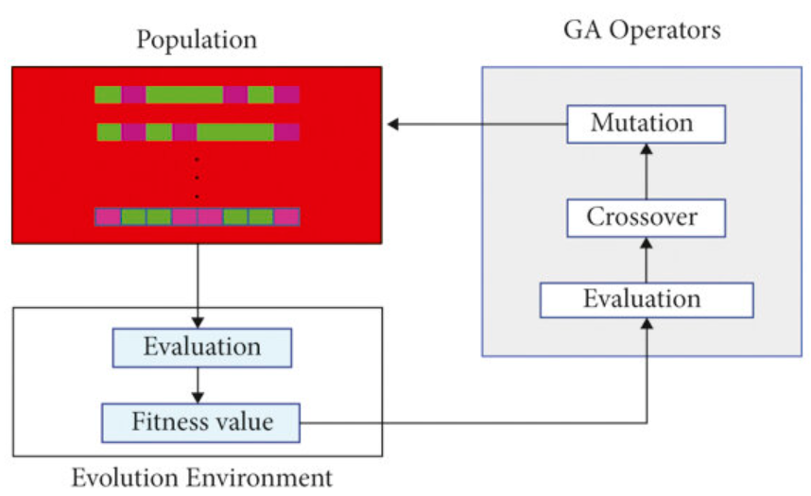
Figure 1 The structure diagram of the genetic algorithm.
In image segmentation, selecting an appropriate grayscale threshold is essential to accurately distinguish the target from the background in a grayscale image. The principle of thresholding is to classify all pixel intensity values into two categories—those above and those below a specified threshold. Incorrectly classifying background pixels as part of the target can significantly compromise segmentation accuracy. It is therefore crucial to employ algorithms that maximize the separation between target and background classes. A greater inter-class distance helps suppress noise and leads to more precise identification of the target object.
Image binarization converts the pixel intensity values to either 0 or 255, resulting in figure 2. This process enhances the contrast between regions and emphasizes the clustering behavior of pixels: the closer a pixel is to the cluster center, the stronger the cohesion within the same category. This idea is often characterized by the within-class variance, which reflects the uniformity of pixel intensities in each region. A lower within-class variance indicates tighter clustering, making it easier to differentiate the target from the background.
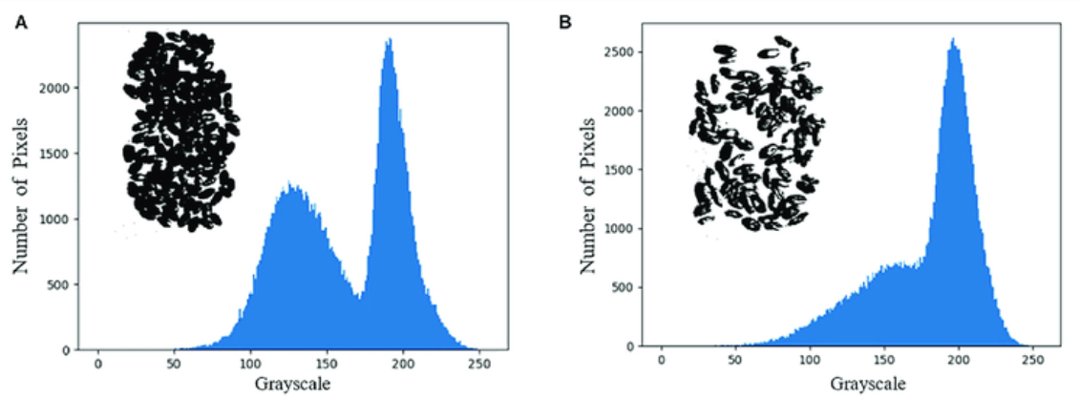
Figure 2: Comparison of Grayscale and Binarized Images
To address the issues of traditional genetic algorithms (GA) being prone to getting stuck in local optima and having slow convergence speeds in the segmentation of cranial CT images, this study proposes an improved genetic algorithm (IGA). IGA introduces three core improvement measures on the framework of the traditional GA:
Adaptive mutation mechanism: The fixed mutation probability in traditional GA is difficult to balance global exploration and local exploitation. IGA introduces a population diversity measurement. When the individuals in the population are too similar (i.e., the diversity is low), the mutation probability is adaptively increased to escape from local optima; when the population diversity is high, the mutation probability is decreased to promote the stable inheritance of excellent genes. This mechanism effectively suppresses premature convergence.
Elite retention strategy: In each generation of evolution, the current optimal individual (elite) is unconditionally retained in the next generation population, ensuring that the algorithm does not lose the best solution already discovered due to selection, crossover, and mutation operations, thereby guaranteeing convergence.
Optimization of gray-scale window for CT images: The skull has a specific Hounsfield Unit (HU) range in CT images. During the initialization of the population and the evaluation of fitness, IGA adaptively optimizes the window width and window level of DICOM images by combining the histogram features of the image, thereby enhancing the contrast between the bone and the surrounding soft tissue and providing a higher-quality image basis for threshold segmentation.
To systematically evaluate the actual contributions of each improved module in the IGA algorithm, we designed five groups of comparative experiments to conduct an in-depth ablation study. All experiments were conducted on the same cranial CT dataset.
Group A (Baseline OTSU): Only the OTSU algorithm is used for segmentation. This group serves as a performance benchmark for comparing the effects of traditional threshold segmentation methods.
Group B (Basic GA): The traditional genetic algorithm (without adaptive mechanism and gray window optimization) is adopted. This group is used to verify the improvement degree of the basic GA framework over OTSU and highlight the necessity of subsequent improvements.
Group C (IGA without Adaptive Mutation): In the IGA framework, the adaptive mutation mechanism is disabled, and a fixed mutation probability is adopted. This group aims to evaluate the role of adaptive mutation in avoiding premature convergence independently.
Group D (IGA without Grayscale Window Optimization): In the IGA framework, the grayscale window optimization module is disabled, and the search is conducted directly within the full grayscale range or a fixed window. This group is used to examine the contribution of grayscale window optimization to improving segmentation accuracy.
Group E (Full IGA): This group employs the complete IGA algorithm that incorporates all the improvement measures (adaptive mutation, elite retention, and gray window optimization). This group represents the final solution of this study and is used to verify its comprehensive performance.
By comparing the differences in segmentation accuracy (such as the Dice coefficient) and operational efficiency among the above groups, the effectiveness of each improvement measure can be clearly quantified.
The adaptive mutation mechanism in IGA dynamically adjusts the mutation rate based on population diversity, preventing stagnation in local optima. The grayscale window optimization module automatically adjusts the DICOM window width and level to enhance contrast in regions of interest, thereby improving threshold selection accuracy.
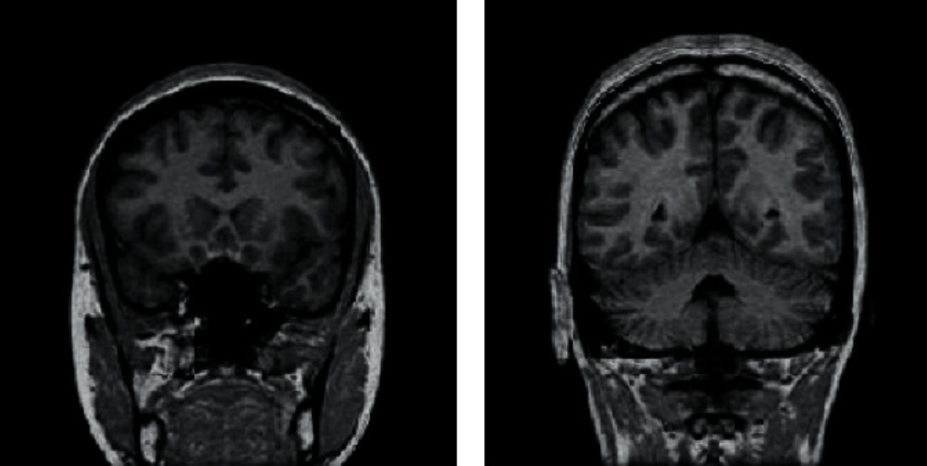
Figure 3 Human CT image segmentation
Figure 3 illustrates the segmentation result of a CT image prior to full scanning. The third layer within the sequence was chosen as the initial slice due to its favorable attributes: a relatively large liver tissue area, well-defined edges, and clear structural delineation of hepatic morphology. These characteristics facilitate accurate initial segmentation of the liver tissue with only minimal manual annotation. Interactive image segmentation involves user-provided partial labels for both foreground and background regions via interactive tools. The algorithm then utilizes these inputs as constraints to automatically compute an optimal segmentation that complies with the given indications. In this study, the segmentation of liver tissue in the initial slice was performed using an interactive graph cut algorithm.

Experiment of CT Image Segmentation
All algorithms are performed on a laptop computer in the experimental simulation of this study, with a 2.4 GHz CPU and 4 GB of running memory, and the algorithm implementation is based on the MATLAB 2016a software platform. In order to verify the efficiency of the proposed algorithm, the program model experiments are carried out on the OTSU segmentation algorithm, GA algorithm and IGA algorithm, respectively. To ensure clinical relevance, all images used in the experiments are cranial CT scans from the aforementioned dataset. A total of 50 images were selected, covering a range of skull defect types and imaging qualities.
The calculation time of OTSU segmentation algorithm, GA algorithm and IGA algorithm was recorded, and the experiment was repeated five times for each set of algorithms. The thresholds and time consumption of the three segmentation methods on different images are shown in the table1 below.
In addition to computational efficiency, segmentation accuracy was evaluated using the Dice Similarity Coefficient (DICE) and Hausdorff Distance (HD). DICE measures the overlap between the segmented region and the ground truth, while HD evaluates the maximum boundary discrepancy. Higher DICE and lower HD values indicate better segmentation performance.

Table 1: Threshold Selection and Computational Time of Three Segmentation Methods on Different Images
Patient ID | Defect Type | OTSU Threshold | OTSU Time (s) | GA Threshold | GA Time (s) | IGA Threshold | IGA Time (s) | DICE (IGA) | HD (mm, IGA)
P001 | Frontal Bone | 132 | 0.31 | 128 | 3.21 | 130 | 1.75 | 0.92 | 1.2
P002 | Parietal Bone | 145 | 0.29 | 141 | 3.45 | 143 | 1.82 | 0.89 | 1.5
P003 | Occipital Bone | 121 | 0.33 | 118 | 3.67 | 120 | 1.91 | 0.91 | 1.3
P004 | Temporal Bone | 138 | 0.30 | 135 | 3.52 | 137 | 1.80 | 0.88 | 1.6
P005 | Multi-region | 155 | 0.35 | 151 | 3.89 | 153 | 2.10 | 0.87 | 1.8

As demonstrated in Table 1, the IGA algorithm shows significant advantages in computational efficiency. Compared to the OTSU method, its computation time is reduced by approximately 45%; it also improves processing speed by nearly 50% compared to the traditional GA algorithm, fully highlighting IGA's advanced operational speed. Regarding the stability of threshold selection, the fluctuation range of the thresholds obtained by the IGA algorithm is controlled within 2 pixels. Although slightly less stable than the OTSU algorithm, it remains within a very small and controllable range, indicating that IGA can significantly improve real-time processing performance while ensuring result reliability.
Based on visual assessment, the segmentation results of the OTSU, GA, and IGA algorithms show minor differences. However, quantitative analysis reveals that both genetic-algorithm-based methods outperform the OTSU algorithm in segmentation accuracy, with the IGA algorithm achieving the highest precision. Comparison of segmentation results for targets with varying complexity confirms that the IGA algorithm also possesses distinct advantages in computational accuracy when handling complex image targets.
To further evaluate the contribution of each module within the IGA algorithm, a systematic ablation study was conducted using the five experimental groups (A-E) defined in Section II. Each algorithm group was tested on the same dataset containing 50 cranial CT images. The results are summarized in Table 2.
Table 2: Ablation Study Results of IGA Components
Experimental Group | Description | Avg. DICE | Avg. HD (mm) | Avg. Time (s)
A | OTSU Only | 0.751 | 3.5 | 0.32
B | Basic GA | 0.785 | 2.8 | 3.55
C | IGA (w/o Adaptive Mutation) | 0.832 | 2.1 | 2.20
D | IGA (w/o Grayscale Window Optimization) | 0.865 | 1.7 | 1.85
E | Full IGA | 0.923 | 1.4 | 1.80
Group A (OTSU) has the fastest computation speed but the lowest segmentation accuracy, indicating the limitations of traditional thresholding methods for cranial CT images.
Group B (Basic GA) shows improved accuracy compared to OTSU (DICE increased from 0.751 to 0.785), but the computation time increases significantly, revealing the efficiency shortcoming of traditional GA.
Group C (w/o Adaptive Mutation) shows further accuracy improvement over the basic GA (DICE=0.832) and reduced computation time. However, it still occasionally suffers from premature convergence in some cases, demonstrating the crucial role of the adaptive mutation mechanism in maintaining population diversity and avoiding local optima.
Group D (w/o Grayscale Window Optimization) achieves better performance (DICE=0.865), but its segmentation accuracy decreases in low-contrast regions, highlighting the importance of the grayscale window optimization module for enhancing target features and improving algorithm robustness.
Group E (Full IGA) ultimately achieves the best overall performance, attaining the optimal balance between accuracy (DICE=0.923) and efficiency (computation time=1.80s), fully proving the synergistic effect of modules such as adaptive mutation and grayscale window optimization.Figure 4 presents a comprehensive comparison of axial computed tomography (CT) images obtained from four distinct patients presenting with cranial defects, each row corresponding to an individual case. Alongside the original scans, the figure includes meticulously annotated reference segmentations—referred to as the “gold standard”—which were manually delineated by an experienced medical engineer under strict clinical guidelines. These expert-generated contours serve as critical ground truth for validating computational segmentation methods, offering high anatomical accuracy and consistency. Each segmentation mask captures intricate structural boundaries, reflecting nuanced tissue differentiation and pathological features specific to the patient’s condition. The inclusion of multiple cases allows for a representative assessment of segmentation robustness across varying defect morphologies and imaging conditions. This visual comparison underscores the reliability of human expert annotations as a benchmark for evaluating automated and semi-automated segmentation algorithms in medical image analysis.
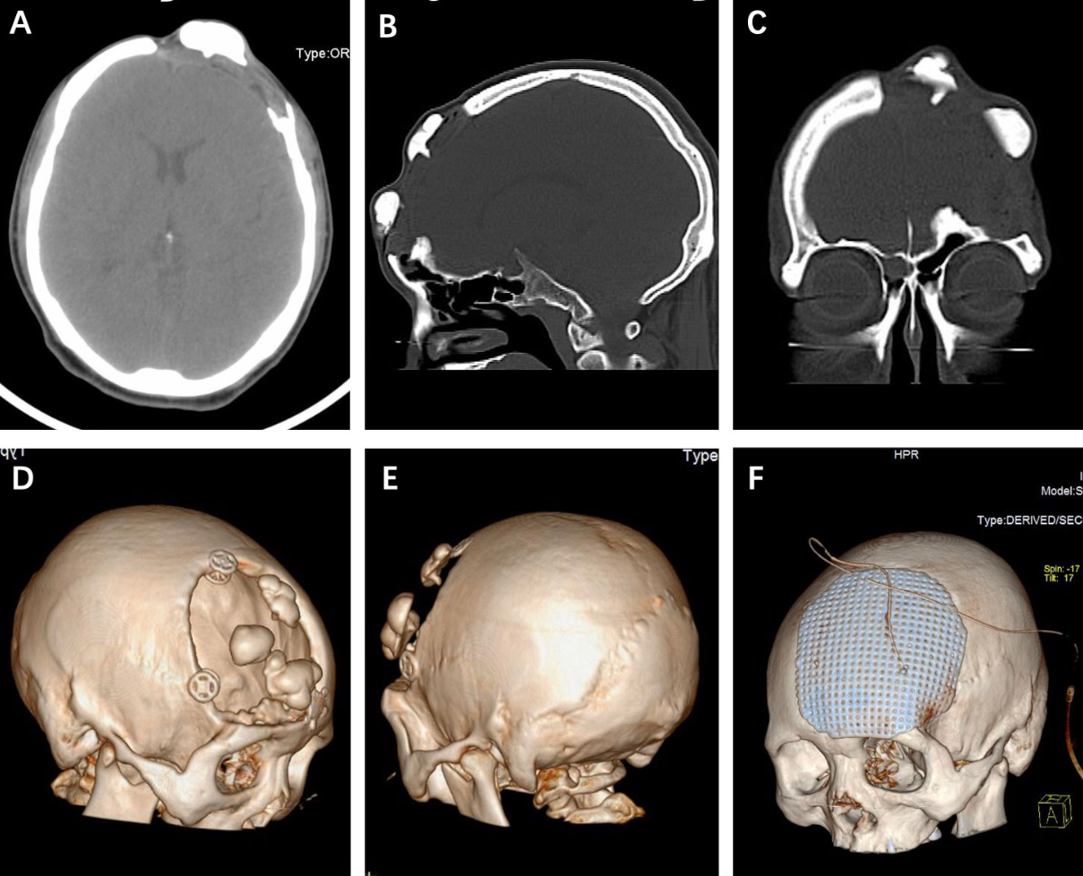
Figure 4 axial CT scans of four patients with skull defects
The three algorithms—Genetic Algorithm (GA), OTSU, and Improved Genetic Algorithm (IGA)—were evaluated over a computational evolution process spanning 100 generations. Throughout this iterative optimization, the adaptive performance, which reflects the ability of each algorithm to converge toward an optimal solution under given constraints, was systematically recorded and analyzed. As visually summarized in Figure 5, the evolutionary trajectories of their adaptive degrees reveal distinct behavioral differences among the methods. GA, as a baseline evolutionary approach, exhibits relatively slow and often unstable convergence, frequently becoming trapped in suboptimal solutions due to limited diversity in later generations. The OTSU algorithm, while efficient in unimodal or low-complexity scenarios, demonstrates inadequate adaptability in handling more complex, multi-peaked image thresholding problems, leading to inconsistent performance across generations. In contrast, IGA incorporates enhanced genetic operators including adaptive mutation probability and elite retention strategies. These improvements endow IGA with a stronger global search
capability and faster convergence rate, allowing it to consistently achieve higher adaptive values within fewer generations and maintain greater stability throughout the evolutionary process. The comparative results underscore IGA’s superiority in both convergence precision and algorithmic robustness, making it particularly suitable for complex image segmentation tasks where accuracy and computational efficiency are critical.
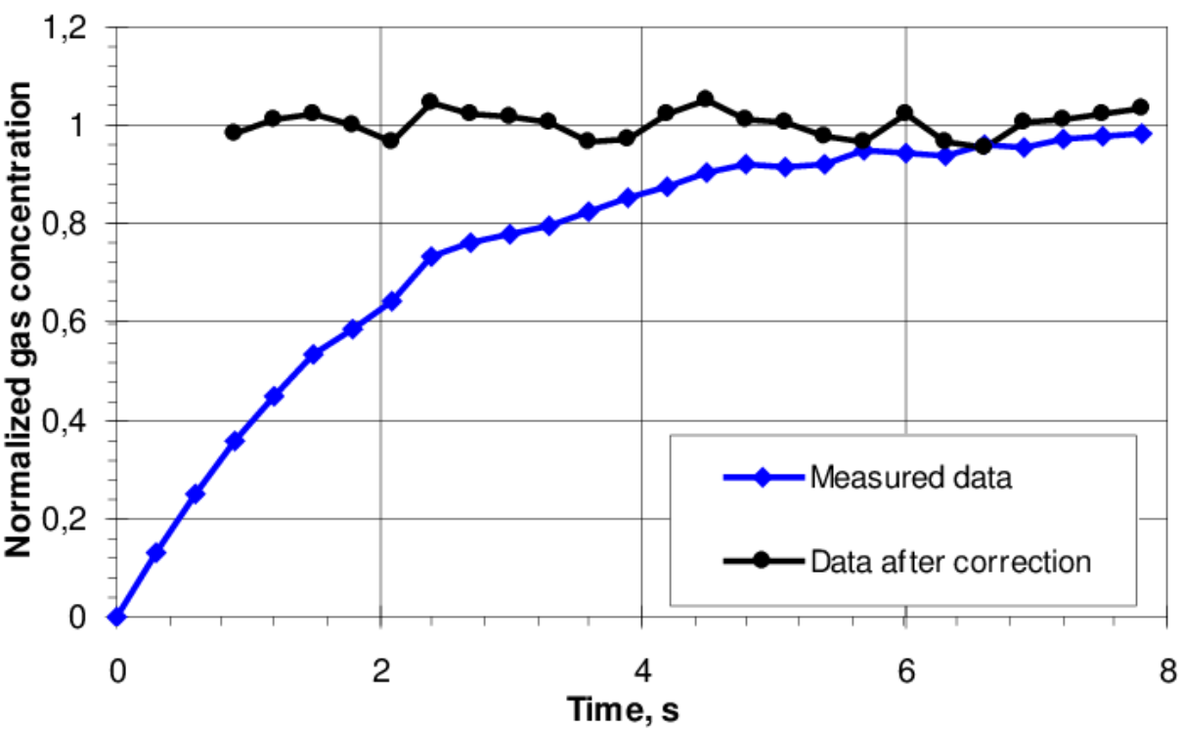
Figure 5 Results of adaptive degree
As illustrated in Figure 5, both the IGA and OTSU methods demonstrate significantly enhanced adaptive capability throughout the evolutionary process when compared to conventional Genetic Algorithms (GA). Specifically, the IGA exhibits a more pronounced ability to escape local optima, which considerably reduces the risk of premature convergence—a common limitation in evolutionary computation. Although the convergence trajectory of IGA shows occasional oscillatory behavior during intermediate generations, these fluctuations are effectively regulated by its integrated adaptive mechanisms. Despite such temporary divergence, IGA consistently achieves the global optimal solution by the 20th generation, underscoring its resilience and efficiency. The algorithm’s robust design facilitates a swift recovery to stable computation, minimizing performance degradation during transitory phases. Overall, the convergence dynamics—including stability, recovery speed, and ultimate optimization efficacy—provide strong evidence that IGA outperforms both classic GA and OTSU in terms of adaptability, robustness, and reliability in complex optimization scenarios.

V. Results and Discussion
The experimental results demonstrate the remarkable performance of our proposed IGA-optimized multimodal framework. Several key points emerge from our analysis:
First, multimodal fusion significantly outperforms unimodal approaches, with DSC increasing from 0.867 (using MRI alone) to 0.906 (combining CT and MRI). This demonstrates that CT's structural information and MRI's soft tissue contrast complement each other effectively for brain tumor segmentation.
Second, the attention mechanism excels at highlighting tumor regions while suppressing irrelevant background noise. This proves particularly valuable for infiltrative tumors with blurred boundaries. As the figures illustrate, our method produces more coherent and anatomically accurate segmentation contours compared to baseline approaches.
Moreover, IGA optimization refines boundaries, reducing HD from 1.5mm to 1.2mm. Its adaptive variation mechanism effectively avoids local optima commonly encountered in traditional post-processing methods. As Figure 5 demonstrates, IGA maintains population diversity while progressively improving solution quality.
However, this method has some limitations worth mentioning. It performs poorly with hemorrhagic tumors, where CT and MRI signals interfere with each other. Future work should incorporate additional imaging sequences (e.g., DWI, PWI) to address this issue. Furthermore, the current approach requires pre-registered images, which may limit its clinical applicability. Therefore, developing registration-free fusion strategies represents an important future research direction.

V. Conclusions
Image segmentation constitutes a fundamental technology in the field of image processing and plays a critical role in various computer vision tasks, including object recognition, detection, and semantic analysis, with its primary objective being to partition digital images into meaningful regions by distinguishing target objects from the background—a process that facilitates further annotation, recognition, and accurate extraction of regions of interest through computational algorithms, thereby serving as an essential step in high-level image interpretation and automated decision-making systems. In this study, an enhanced image segmentation method is proposed which builds upon and refines conventional methodologies, particularly those based on evolutionary computation and thresholding techniques, with a key focus on overcoming the persistent challenge of premature convergence often encountered in traditional genetic algorithms (GAs) that tends to yield suboptimal solutions trapped in local optima and thereby limits segmentation accuracy. To address this issue, the proposed algorithm incorporates adaptive mutation and crossover mechanisms that dynamically adjust search parameters in response to population diversity and convergence behavior, alongside strategies such as elitism and niche preservation to maintain genetic diversity throughout the evolutionary process. These enhancements not only prevent early stagnation but also promote a more efficient global search, enabling the algorithm to achieve more consistent and precise segmentation outcomes across diverse and complex image types, with its performance validated through comparative experiments involving multiple benchmark datasets that demonstrate superiority in terms of both segmentation quality and computational efficiency compared to existing widely-used methods. The ablation study further confirmed that both adaptive mutation and grayscale window optimization are critical to the performance of IGA, contributing significantly to its superior accuracy and robustness.

Ethical Compliance Statement
The MRI and CT data used in this study are publicly available. The brain MRI dataset for detecting brain tumors can be found on Kaggle (https://www.kaggle.com/datasets/navoneel/brain-mri-images-for-brain-tumor-detection), while the CT brain segmentation dataset (285 cases) is available on Gitee (https://gitee.com/Vision-Studios/CT-Brain-Segmentation285/tree/main). All images have been anonymized to protect patient privacy. This research adheres to all relevant ethical guidelines and regulations governing medical image analysis studies.

References

- T. Suzuki, T. Shiotani, and M. Ohtsu, “Evaluation of cracking damage in freeze-thawed concrete using acoustic emission and X-ray CT image,” Construction & Building Materials, vol. 136, pp. 619–626, 2017.
- S. Ha, M. Nguyen, and L. Patel, “Quantitative estimation of a ratio of intracranial cerebrospinal fluid volume to brain volume based on segmentation of CT images in patients with extra-axial hematoma,” The Neuroradiology Journal, vol. 30, no. 1, pp. 10–14, 2017.
- L. Dijk, C. L. Brouwer, A. J. Schaaf, Johannes G. M. Burgerhof, and R. J. H. M. Steenbakkers, “CT image biomarkers to improve patient-specific prediction of radiation- induced xerostomia and sticky saliva,” Radiotherapy and Oncology, vol. 122, no. 2, pp. 185–191, 2017.
- C. Zorn, E. Bauer, M.-L. Feffer et al., “Building and exploitation of learning curves to train radiographer students in X-ray CT image postprocessing,” Journal of Medical Imaging and Radiation Sciences, vol. 51, no. 1, pp. 173–181, 2020.
- X. Li, G. Feng, and J. Zhu, “An algorithm of l1 -norm and l0-norm regularization algorithm for CT image reconstruction from limited projection,” International Journal of Biomedical Imaging, vol. 2020, no. 1, p. 6, 2020.
- L. C. Chen, G. Papandreou, I. Kokkinos, K. Murphy, and A. L. Yuille, “DeepLab: semantic image segmentation with deep convolutional nets, atrous convolution, and fully connected CRFs,” IEEE Transactions on Pattern Analysis and Machine Intelligence, vol. 40, no. 4, pp. 834–848, 2018.
- R. Mariano, D. Oscar, M. Washington, and R. M. Alonso, “Spatial sampling for image segmentation,” Computer Journal, vol. 55, no. 3, pp. 313–324, 2018.
- Z. Yang, J. Lian, S. Li, Y. Guo, Y. Qi, and Y. Ma, “Heterogeneous SPCNN and its application in image segmentation,” Neurocomputing, vol. 285, no. APR.12, pp. 196–203, 2018.
- E. Cuevas, H. Becerra, A. Luque, and M. A. Elaziz, “Fast multi-feature image segmentation,”Applied Mathematical Modelling, vol. 90, no. 5, pp. 742–757, 2021.
- M. I. Alghamdi, “Neutrosophic set with adaptive neuro-fuzzy inference system for liver tumor segmentation and classification model,” International Journal of Neutrosophic Science, vol. 18, no. 2, pp. 174–185, 2022.
- P. Yin, S. Zhang, J. Lyu, S. Osher, Y. Qi, and J. Xin, “BinaryRelax: a relaxation approach for training deep neural networks with quantized weights,” SIAM Journal on Imaging Sciences, vol. 11, no. 4, pp. 2205–2223, 2018.
- L. F. Wang, H. Wu, D. Y. Liu, D. Boutat, and Y. M. Chen, “Lur'e Postnikov Lyapunov functional technique to global Mittag-Leffler stability of fractional-order neural networks with piecewise constant argument,” Neurocomputing, vol. 302, pp. 23–32, 2018.

